**PRACTICAL No.9**

**AIM:Write a Program to find simple interest from given principal, rate of interest and number of years.**

**STEPS:**

#Write a Program to find simple interest from given principal, rate of interest and number of years.

p=int(input("Enter Amount "))

r=int(input("Enter Rate of interest "))

n=int(input("Enter Number of years "))

c=(p*r*n)/100

print(c)

___________________________________________________________________________________________________________________________________________________________________________________________________________________________________________________________________________________________________________________________________________________________________________________________________________________________________________________________________________________________________________________________________________________________________________________________________________________________________________________________________________________________________________________________________________________________________________________________________________________________________________________________________________________________________________________________________________________________________________________________

**SCREENSHOT:**

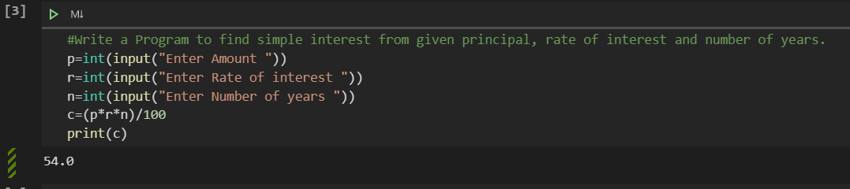

**Date:**